TRAVEL BHARAT – Implementation Plan
Internship Project | Unified Mentor x Incredible India
A centralized tourism information platform providing state-wise and city details of the destination across India.

Excecutive Summary
TravelBharat will be a full-stack tourism web application with a vanilla HTML/CSS/JS frontend (styled with Tailwind CSS), Node.js/Express.js backend with EJS templating, and PostgreSQL database. The platform lets users explore India's 28 states and 8 union territories, discover tourist destinations by category, and view rich destination pages with images, descriptions, and travel information.
The project is a single Express.js application that serves both the rendered HTML pages and the REST API. This architecture keeps things simple while delivering a professional, full-stack product.

Tech Stack (Finalized)
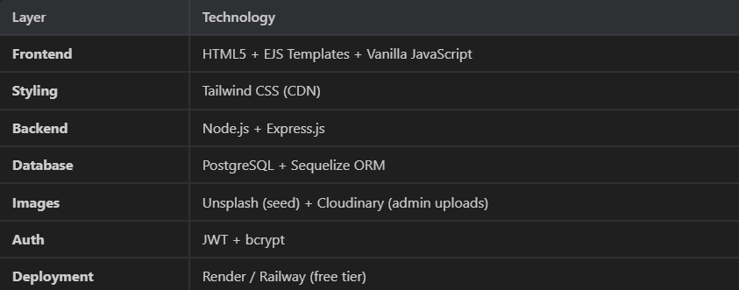
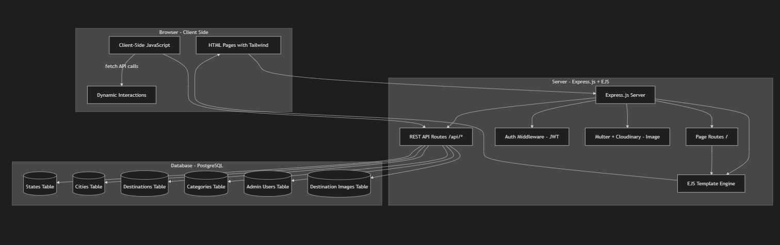
- A tourism site needs dynamic pages – you cant manually create an HTML file for each of 100+ destinations. EJS templates let you write HTML(exactly like regular HTML) but inject data from PostgreSQL dynamically.

Technology Stack:

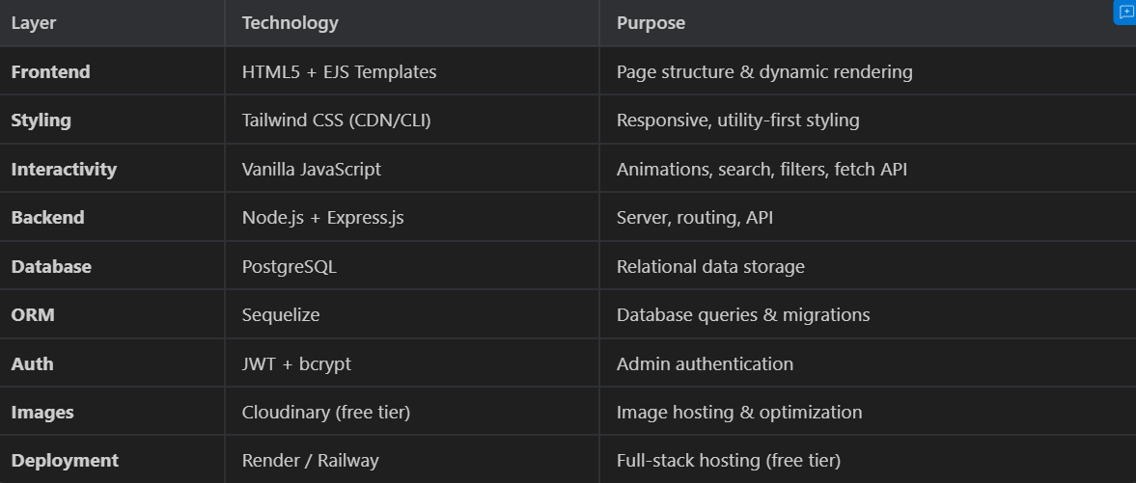

Project Structure:

TravelBharat/
├── public/ # Static assets (served by Express)
│ ├── css/
│ │ └── styles.css # Tailwind output + custom styles
│ ├── js/
│ │ ├── main.js # Global scripts (navbar, animations)
│ │ ├── search.js # Search & autocomplete logic
│ │ ├── map.js # Interactive India map
│ │ ├── gallery.js # Image gallery lightbox
│ │ ├── filters.js # Category/region filter logic
│ │ ├── admin.js # Admin panel interactions
│ │ └── animations.js # Scroll reveals, counters, effects
│ ├── images/
│ │ ├── hero/ # Hero section backgrounds
│ │ ├── icons/ # Category & UI icons
│ │ ├── logo/ # TravelBharat logo
│ │ └── og/ # Open Graph images
│ └── india-map.svg # Interactive SVG map of India
│
├── views/ # EJS templates (HTML with data injection)
│ ├── layouts/
│ │ ├── main.ejs # Base layout (head, nav, footer)
│ │ └── admin.ejs # Admin layout (sidebar, header)
│ ├── partials/
│ │ ├── navbar.ejs # Navigation bar
│ │ ├── footer.ejs # Footer
│ │ ├── hero.ejs # Hero section
│ │ ├── state-card.ejs # State grid card
│ │ ├── dest-card.ejs # Destination card
│ │ ├── search-bar.ejs # Global search component
│ │ ├── breadcrumb.ejs # Breadcrumb navigation
│ │ ├── category-badge.ejs # Category tag badge
│ │ ├── pagination.ejs # Pagination component
│ │ ├── image-carousel.ejs # Image carousel/slider
│ │ └── stats-counter.ejs # Animated statistics
│ ├── pages/
│ │ ├── home.ejs # Landing page
│ │ ├── states.ejs # All states listing
│ │ ├── state-detail.ejs # Single state page
│ │ ├── destination-detail.ejs # Single destination page
│ │ ├── explore.ejs # Search & discovery page
│ │ ├── categories.ejs # Categories page
│ │ ├── category-detail.ejs # Destinations by category
│ │ ├── gallery.ejs # Photo gallery page
│ │ ├── about.ejs # About TravelBharat
│ │ └── 404.ejs # Not found page
│ └── admin/
│ ├── login.ejs # Admin login
│ ├── dashboard.ejs # Admin dashboard
│ ├── states.ejs # Manage states (CRUD table)
│ ├── state-form.ejs # Add/Edit state form
│ ├── destinations.ejs # Manage destinations
│ ├── destination-form.ejs # Add/Edit destination form
│ └── categories.ejs # Manage categories
│
├── src/ # Server-side source code
│ ├── config/
│ │ ├── database.js # PostgreSQL + Sequelize setup
│ │ ├── cloudinary.js # Cloudinary configuration
│ │ └── constants.js # App-wide constants
│ ├── models/
│ │ ├── index.js # Model associations & sync
│ │ ├── State.js # State model
│ │ ├── City.js # City model
│ │ ├── Destination.js # Destination model
│ │ ├── Category.js # Category model
│ │ ├── DestinationImage.js # Destination images model
│ │ ├── DestinationCategory.js # Junction table
│ │ └── Admin.js # Admin user model
│ ├── routes/
│ │ ├── pageRoutes.js # HTML page routes (GET /)
│ │ ├── apiStateRoutes.js # API: /api/states
│ │ ├── apiDestRoutes.js # API: /api/destinations
│ │ ├── apiCategoryRoutes.js # API: /api/categories
│ │ ├── apiSearchRoutes.js # API: /api/search
│ │ ├── apiAuthRoutes.js # API: /api/auth
│ │ ├── apiUploadRoutes.js # API: /api/upload
│ │ └── adminRoutes.js # Admin page routes
│ ├── controllers/
│ │ ├── pageController.js # Render HTML pages
│ │ ├── stateController.js # State CRUD logic
│ │ ├── destinationController.js # Destination CRUD logic
│ │ ├── categoryController.js # Category CRUD logic
│ │ ├── searchController.js # Search logic
│ │ ├── authController.js # Login/logout logic
│ │ └── uploadController.js # Image upload logic
│ ├── middleware/
│ │ ├── auth.js # JWT verification
│ │ ├── errorHandler.js # Global error handler
│ │ └── upload.js # Multer file upload config
│ ├── seed/
│ │ ├── data/
│ │ │ ├── states.json # All 36 states/UTs data
│ │ │ ├── cities.json # 60+ cities data
│ │ │ ├── destinations.json # 100+ destinations data
│ │ │ └── categories.json # 4 categories data
│ │ └── seed.js # Database seeder script
│ └── utils/
│ ├── helpers.js # Slug generation, formatting
│ └── validators.js # Input validation functions
│
├── tailwind.config.js # Tailwind CSS configuration
├── package.json # Dependencies & scripts
├── server.js # Express app entry point
├── .env.example # Environment variables template
├── .gitignore
└── README.md # Project documentation

Database Schema (PostgreSQL):
ER Diagram
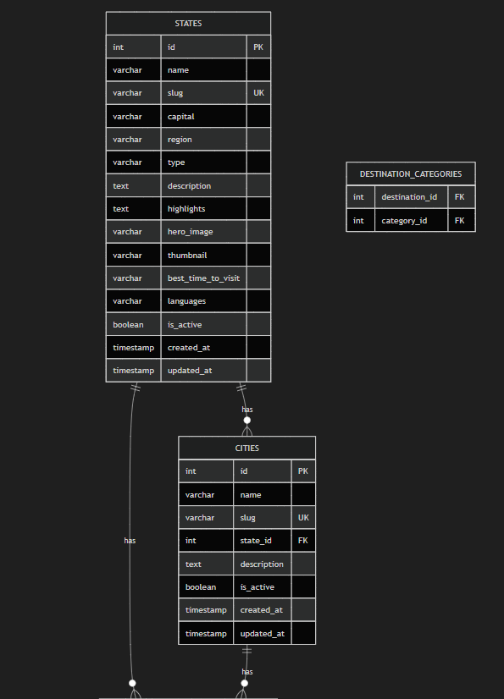
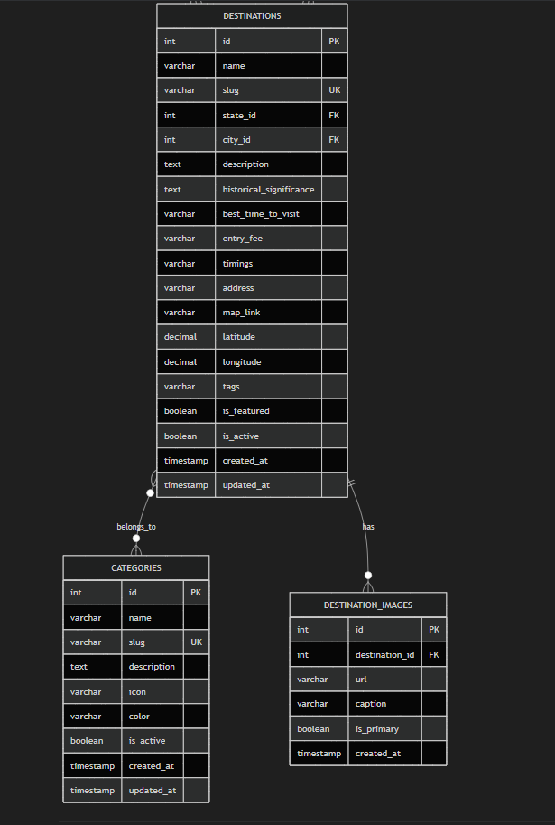
Key Pages
1. Landing Page (Home)
- Hero Section: Full-screen cinematic hero with auto-rotating background images of iconic Indian destinations. Overlaid with animated search bar and tagline: "Discover the Soul of India, One State at a Time"
- Interactive India Map: SVG-based clickable map — hover reveals state name + destination count, click navigates to state page
- Featured States Carousel: Horizontally scrolling cards with glassmorphism effect
- Popular Destinations Grid: 3×2 grid of top destinations with parallax hover effects
- Categories Section: 4 category cards (Heritage, Nature, Adventure, Religious) with gradient overlays
- Statistics Bar: Animated counters — "36 States & UTs | 500+ Destinations | 100+ Cities"
- Footer: Quick links, social links, "Powered by Unified Mentor" badge
2. States Listing Page (/states)
- Region-based tab filters (North, South, East, West, Central, Northeast)
- Grid layout with state cards showing thumbnail, name, capital, destination count
- Search within states
3. State Detail Page (/states/:slug)
- State hero banner with parallax effect
- Quick facts sidebar (capital, languages, best time, total places)
- Category-wise destination listing
- State gallery section
4. Destination Detail Page (/states/:stateSlug/:destSlug)
- Full-width image gallery with lightbox
- Description + historical significance
- Info cards (best time, entry fee, timings)
- Google Maps embed link
- Nearby attractions cards
- Breadcrumb navigation
5. Explore / Search Page (/explore)
- Full-featured search with autocomplete
- Multi-filter panel: State, Category, Region
- Results grid with destination cards
6. Admin Panel (/admin)
- Dashboard with stats cards
- CRUD tables for States, Destinations, Categories
- Image upload with preview
- Form validation
Animations & Micro-interactions
- Card hover: subtle lift + shadow expansion
- Scroll-triggered reveal animations (Intersection Observer)
- Map state hover: glow + scale effect
- Search dropdown slide animation
- Loading skeleton screens
- Counter animations on statistics section
- Smooth page scroll transitions

API Endpoints Summary:
Public APIs
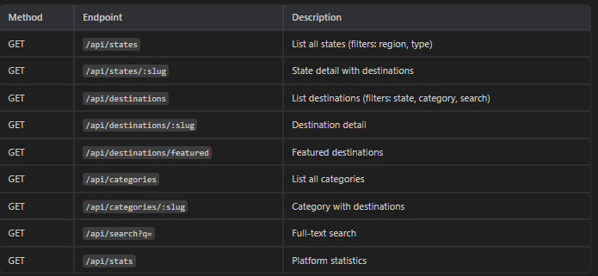
Admin APIs (JWT Protected)
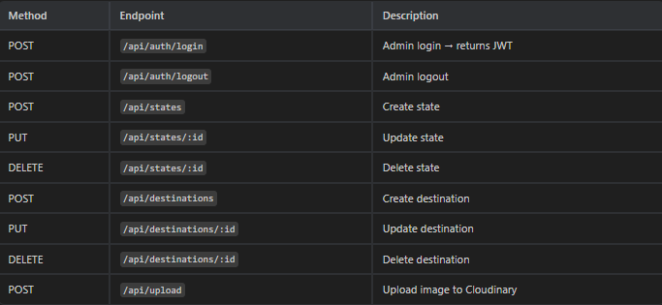
Page Routes (Server-Rendered HTML)
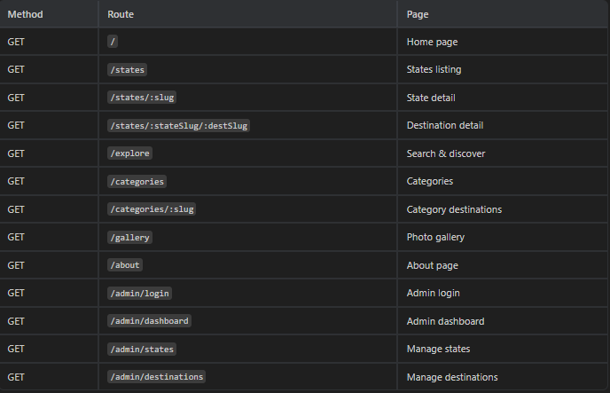
Seed Data Coverage
All 28 states + 8 union territories with:
- States/UTs: 36 entries with descriptions, capitals, regions, hero images
- Categories: Heritage, Nature, Adventure, Religious
- Destinations: 100+ curated tourist places with real descriptions
- Cities: 60+ major cities linked to states
Priority States (10+ destinations each):
- Rajasthan — Jaipur, Udaipur, Jaisalmer, Jodhpur, Pushkar...
- Kerala — Alleppey, Munnar, Kochi, Thiruvananthapuram...
- Uttar Pradesh — Taj Mahal, Varanasi, Lucknow, Mathura...
- Tamil Nadu — Chennai, Madurai, Ooty, Rameswaram...
- Karnataka — Hampi, Mysore, Coorg, Bangalore...
- Himachal Pradesh — Shimla, Manali, Dharamshala, Spiti...
- Goa — Calangute, Basilica of Bom Jesus, Dudhsagar...
- Maharashtra — Mumbai, Pune, Ajanta-Ellora, Lonavala...
- Delhi — Red Fort, India Gate, Qutub Minar, Lotus Temple...
- Jammu & Kashmir — Dal Lake, Gulmarg, Pahalgam...

SEO Strategy
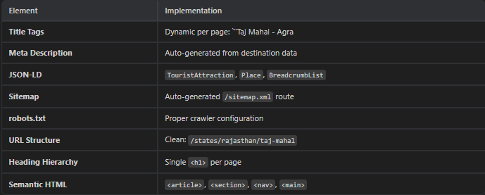
Resolved Decisions
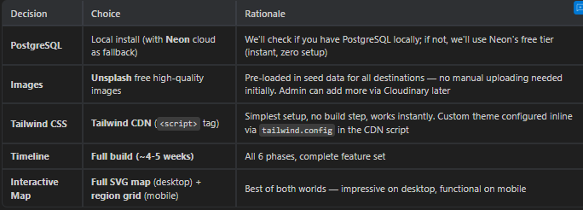
Verification Plan
Automated Testing
- npm run dev — server starts without errors
- Database seeder runs successfully and populates all tables
- All API endpoints return correct data
- All pages render without errors
- Lighthouse audit targeting score ≥ 90
Manual Verification
- Browser testing: Chrome, Firefox, Edge
- Responsive: Mobile (375px), Tablet (768px), Desktop (1440px)
- User flow: Home → State → Destination → Back
- Admin flow: Login → CRUD → Logout
- Search and filter functionality
- Image loading and optimization
Demo Recording
- Browser recording of complete user journey
- Admin panel CRUD demonstration
- Mobile responsive demonstration

Phase Developed Plan
Phase 1: Project Foundation (Days 1-3)
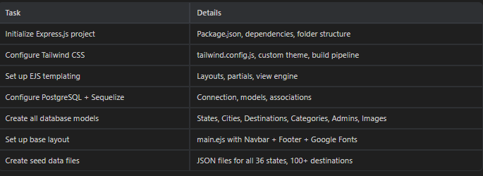
Phase 2: Backend API + Seed Data (Days 4-7)
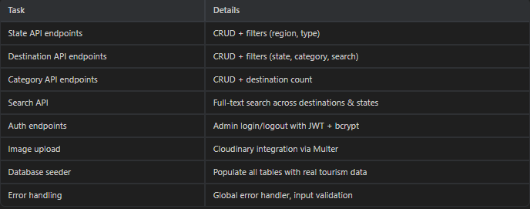
Phase 3: Public Pages(Days 8-14)

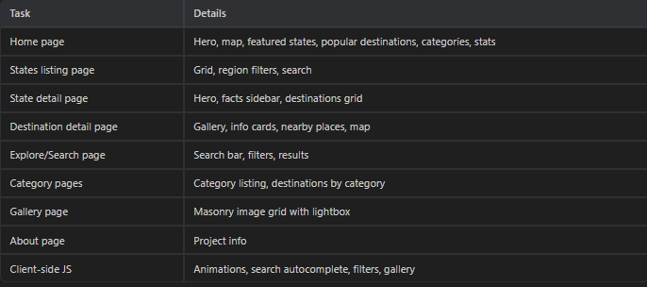
Phase 4: Admin Panel(Days 15-19)
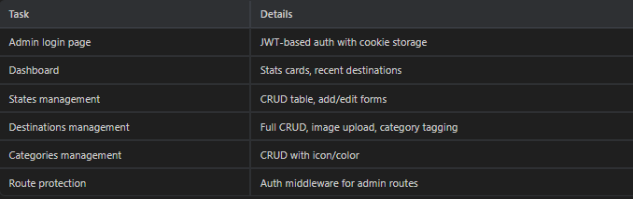
Phase 5: Polish & Optimization (Days 20-23)
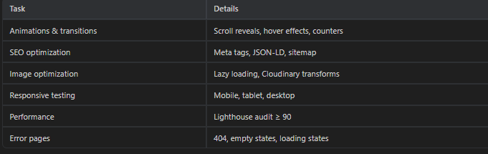
Phase 6: Deployment & Documentation (Days 24-26) 

